Peter Chang, Billy Garcia, Jake Puderbach, Christian Cattaneo

GE1501 14914

Sumo Design Project

Final Report

Dear Professor Whalen,

Below is our final design report for our sumo robot, Blop Bot. You will be able to navigate our report using the table of contents on the next page. There you will find the location of the various information across this document. There is also a list of figures and a list of tables for reference. Our problem is defined early on in Chapter 1 and there is information on how the design for Blop Bot was created in the following chapters. Please pay particular to Chapters 4 and 5 as it goes over the importance of our work and reflects how we can improve in the future. Please read thoroughly as this was a valuable learning experience for us as our first large project as engineers.

Sincerely,

Engineering Group 3

Billy Garcia, Christian Cattaneo, Peter Chang, Jake Puderbach

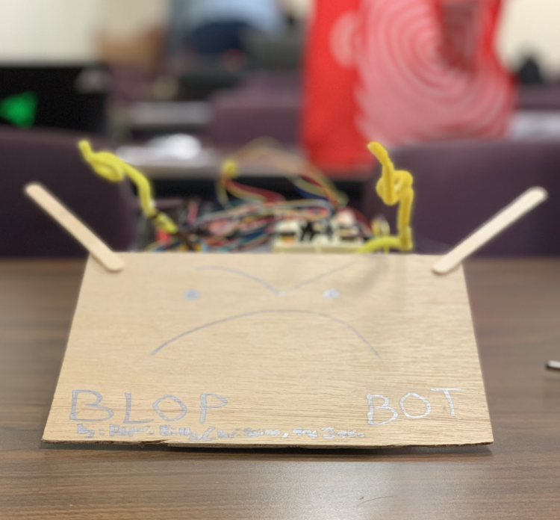

Table of Contents

**Chapter 1:** Problem Definition, Dunker Diagram, KT Situation Analysis (Page 4)

**Chapter 2:** Rank Order Objective Matrix, Brainstorm Results, Idea Sketches, Idea Scores, Idea Scores Explanation, Mental Blocks (Page 6)

**Chapter 3:** AutoCAD Drawings, Final Design Explanation (Page 10)

**Chapter 4:** Conclusion (Page 11)

**Chapter 5:** Recommendations and Reflections (Page 12)

**Appendices:** Source Code (Page 13)

**List of Figures:**

Figure 1- Duncker Diagram, page 4

Figure 2- KT Situation analysis diagram, page 5

Figure 3- Ramp, side view, page 7

Figure 4- Ramp, top view, page 7

Figure 5- More wheels, side view, page 7

Figure 6- More wheels, top view, page 7

Figure 7- Paper underneath, side view, page 7

Figure 8- Robot Autocad, top view, page 10

Figure 9- Robot Autocad, side view, page 10

**List of Tables:**

Table 1- Pairwise comparison, page 6

Table 2- Decision matrix, page 8

**Definitions:**

* Sumo - a Japanese form of heavyweight wrestling, in which a wrestler wins a bout by forcing his opponent outside a marked circle
* Duncker Diagram - generates solutions by creating possible pathways from the present state to the desired state
* Pairwise Comparison - process of comparing entities in pairs to judge which of each entity is preferred, or has a greater amount of some quantitative property, or whether or not the two entities are identical
* Decision Matrix - a list of values in rows and columns that allows an analyst to systematically identify, analyze, and rate the performance of relationships between sets of values and information
* Distance Sensor - sensor able to detect the presence of nearby objects without any physical contact
* Side Sensor - sensor able to detect the edge of the white sumo ring

**Abstract:**

This report contains information regarding our robot, Blop Bot, and the design process that we applied to it. The report begins with a problem definition statement that outlines constraints and objectives we sought to adhere to throughout the competition. We describe the processes we used to define the problem, such as Duncker Diagrams and KT situation analysis. Following this, the brainstorming process is described, including a pairwise comparison table and decision matrix to aide in finding a final implementation. Some mental blocks experienced during brainstorming are illustrated. Sketches of each final idea are displayed, and the decision matrix is explained with the advantages and disadvantages to each solution we decided to include in the matrix. Afterwards, the final design is described and shown via an Autocad drawing. The results of the competition are described in detail, explicitly stating what went well and what did not go well during Blop Bot’s matches. To end the report, a final reflection on the project and competition is displayed.

**Chapter 1 - Introduction and Problem Definition**

Problem Definition:

Our objective is to create modifications to our robot Blop Bot that allows it to have an advantage over its opponents while still adhering to the guidelines. The robot cannot exceed 12 inches in width, 16 inches in length, and 3 pounds in weight. In terms of components allowed or not allowed on the robot, there are restrictions against interfering with other robots. We cannot add anything that would deliberately destroy the other robot. Our first time around we prioritized defense and staying in the circle as much as we could. Now this time around we will attempt to incorporate an offensive approach. We want to incorporate weapons that would impede movement of the opposing robots and possibly confuse their sensors, while still holding strong to our defensive core. We will likely use the same materials from the first robot along with some new additions we will create using our brainstorming techniques.

Duncker Diagram: 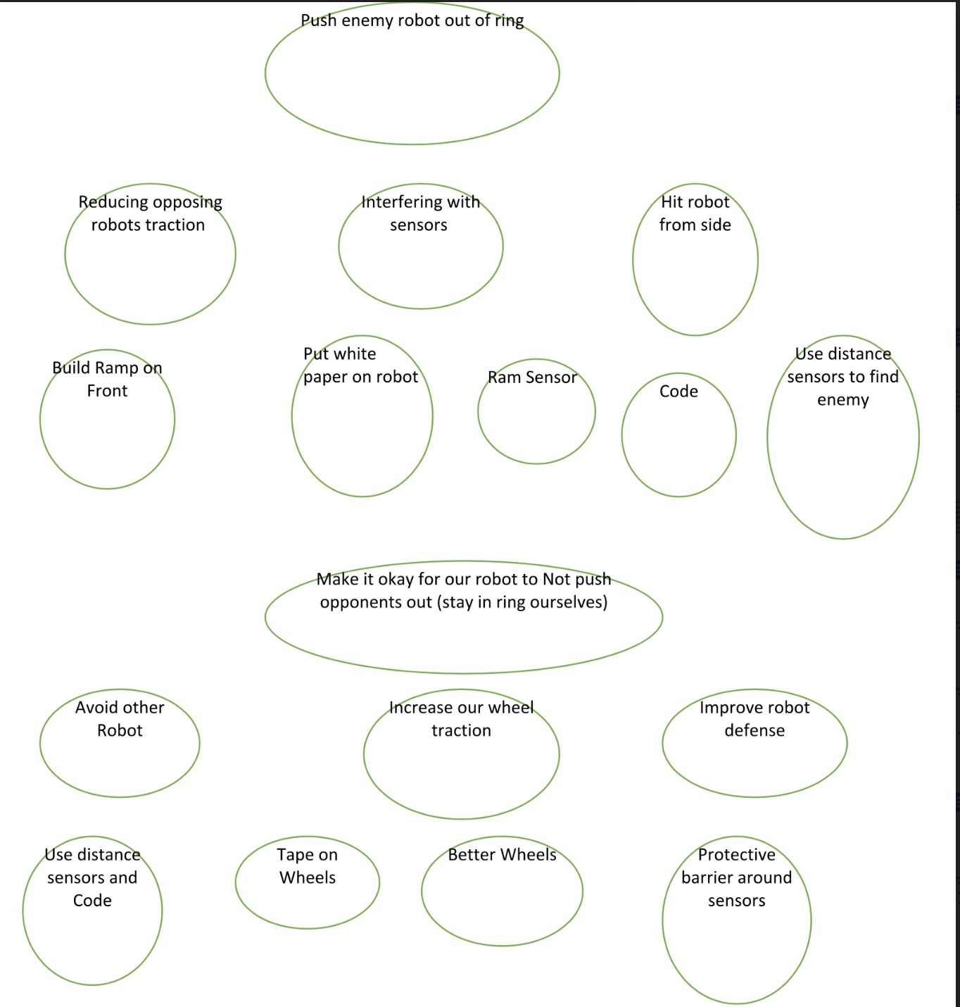

(figure 1)

From the use of the Duncker Diagram, we were able to discern multiple new approaches to tackle the problem at hand, which is to design a winning robot. It helped us to see that there isn’t just one right way to go about improving our current robot, and that no one design is without faults or alternative solutions. Use of the diagram showed us that instead of trying only to create a design that gave the robot offensive capabilities, there were options to create a more defensive robot as well. It opened up a whole new avenue of possible improvements to make on Blop Bot.

KT situation analysis:

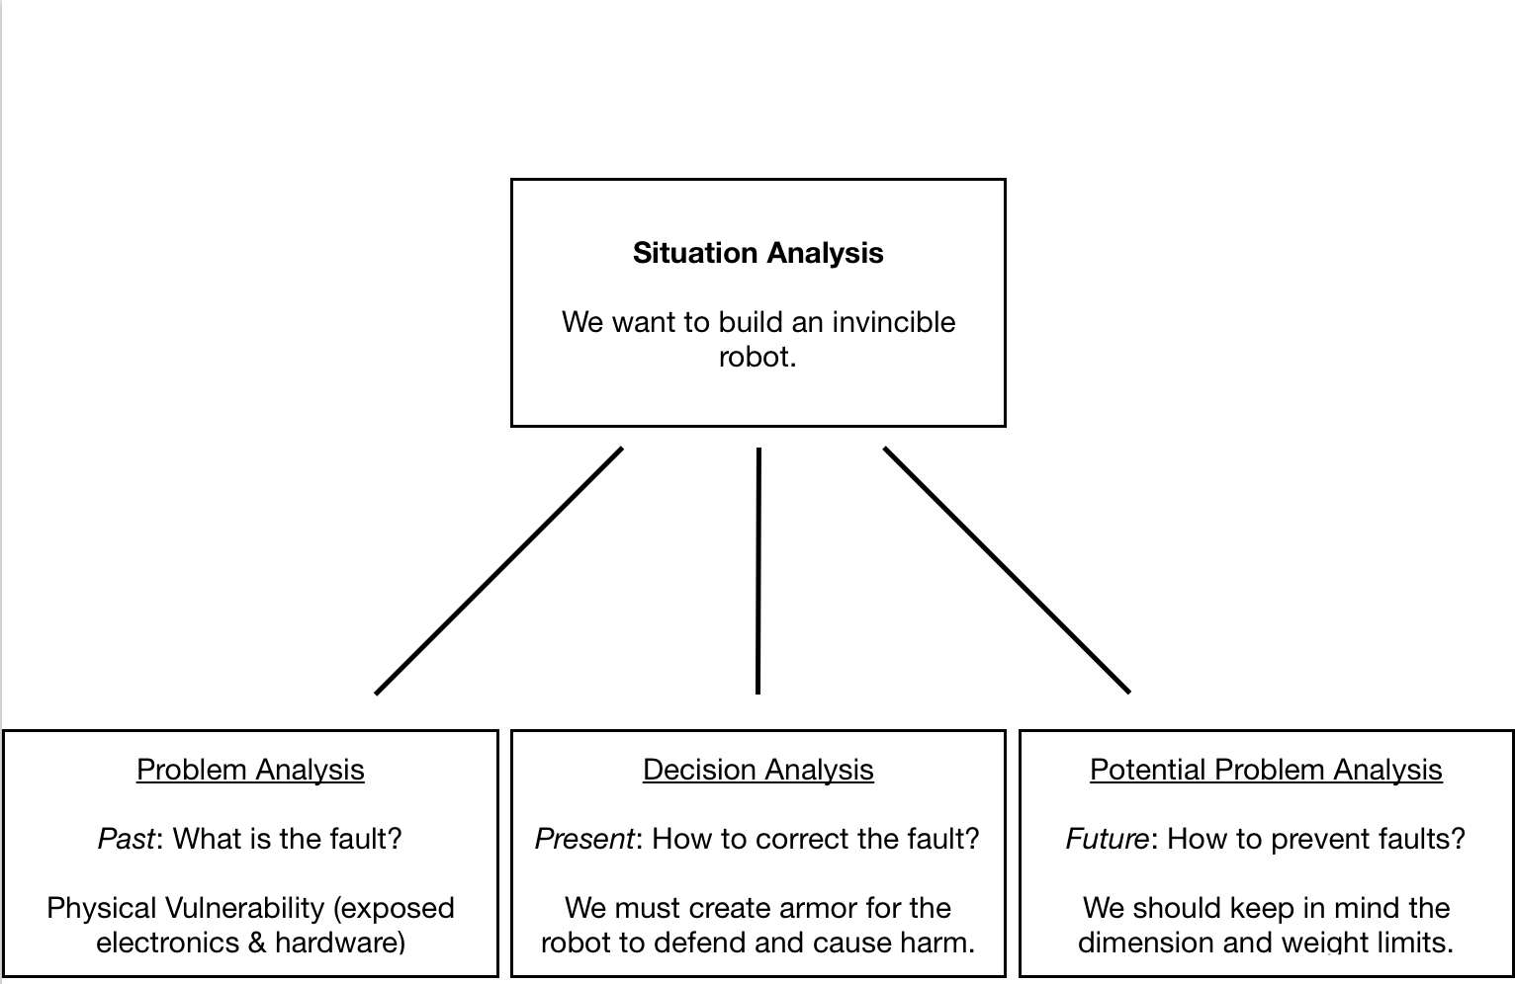

(figure 2)

We learned that there are multiple steps to dealing with the problem at hand. Specifically looking at the defensive capabilities of our robot we were able to brainstorm an armor method to protect our robot while not breaking the constraints given to us by the directions. This technique helped reveal the multiple parts of solving a problem and how each part is equally important.

Overall, the Duncker diagram was more effective in formulating the problem. It provided us with more opportunities to view the problem and its solutions from different angles, as well as making us think critically about how we would apply these solutions physically to our robot.

**Chapter 2 - Generation: Abstraction and Synthesis**

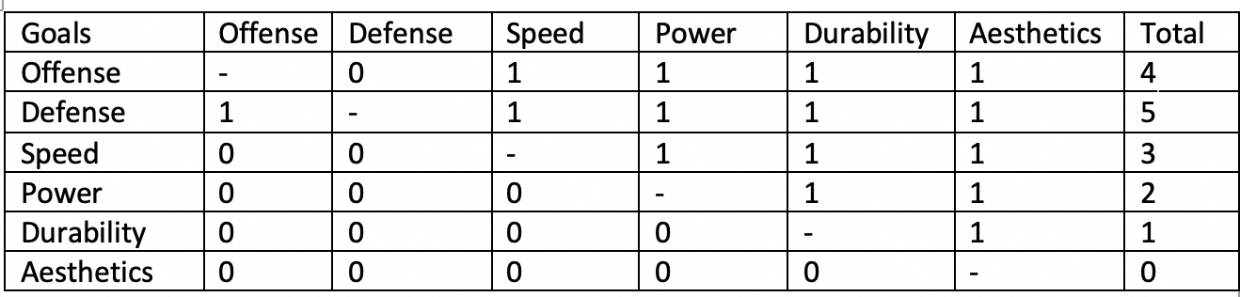

(Table 1)

Based off of the matrix above, defense is the most important objective, followed by offense, speed, power, and durability, and aesthetics dead last. Each held its own merits, however, so we kept each in mind while we brainstormed ideas for design additions. We tried to think of ideas that contained at least one these objectives.

Brainstorm Ideas -

* Ramp on front
* Side spike
* Ramp Trap
* Add traction to wheels
* Something to trigger side sensors
* Back sensor
* Remove distance sensor and build ramp
* Side bar
* New wheels
* Add buzzer for intimidation
* Distance sensors on both sides
* Sound to interfere with distance sensors
* Sticky Ramp

Here are the ideas that we were able to come up with. While brainstorming, we watched some videos from the first sumo competition, and some real sumo wrestlers, to help give us a basis for ideas. We also referred to our previously created Duncker diagram and formulated some attachments that helped fulfill some of the points of it. Eventually, after we finished the process, we discarded the less viable and serious ideas, as well as the ones that focused mainly on less important objectives, and we were left with five alternate solution options. We used a decision matrix to aid in picking final implementations.

Idea Sketches:

(figures 3-7, from top left) 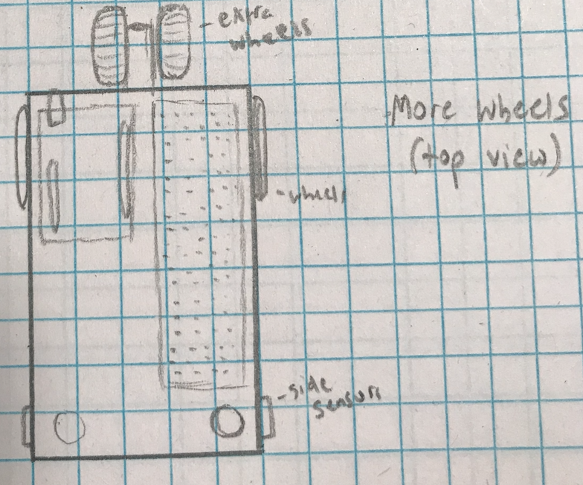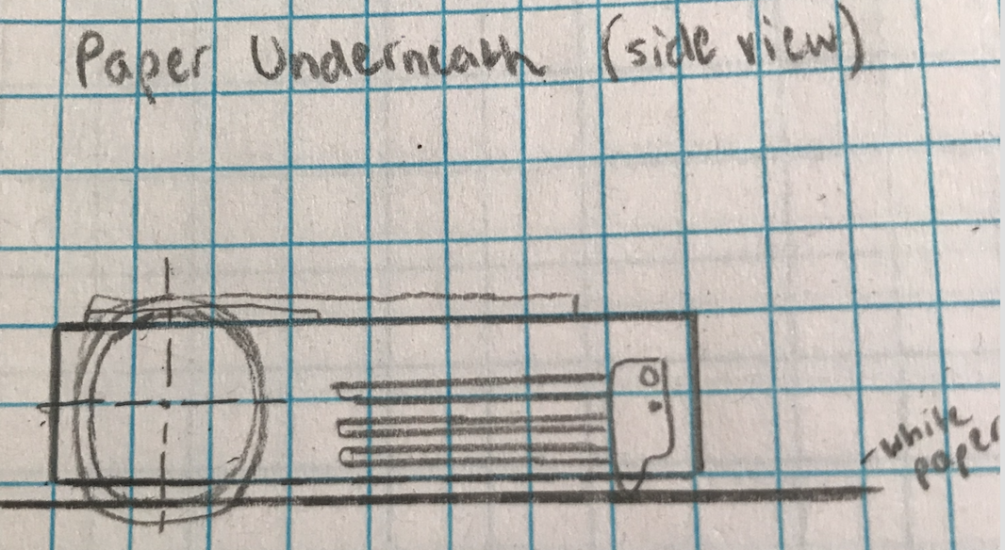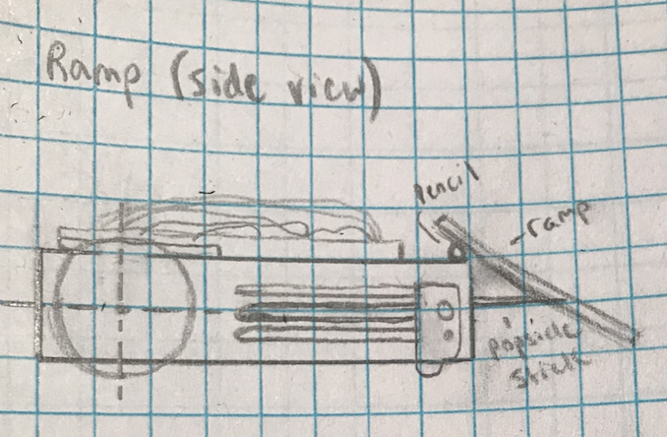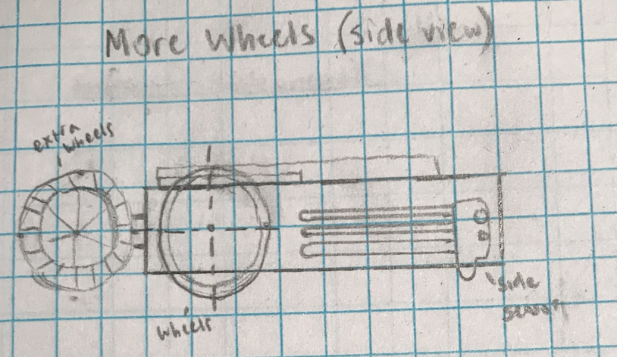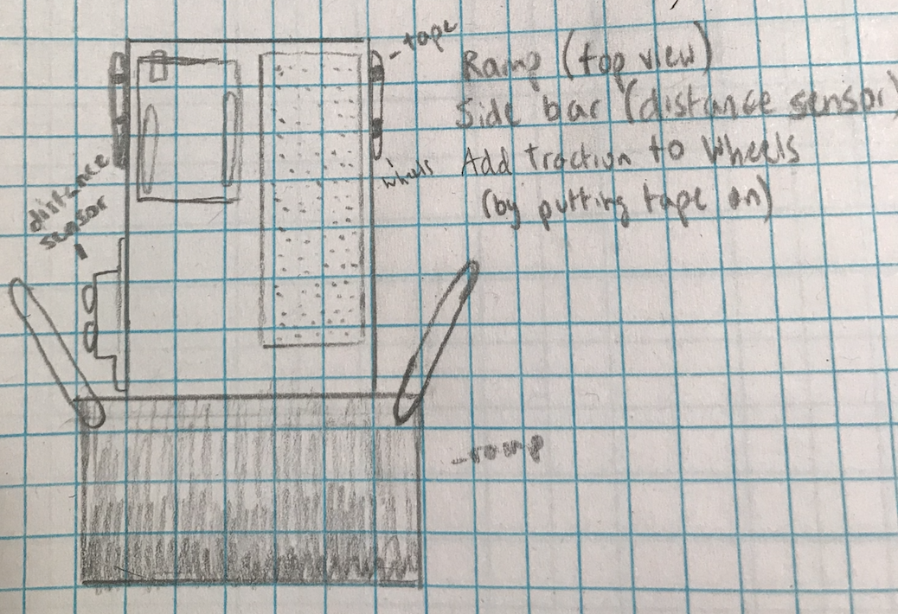

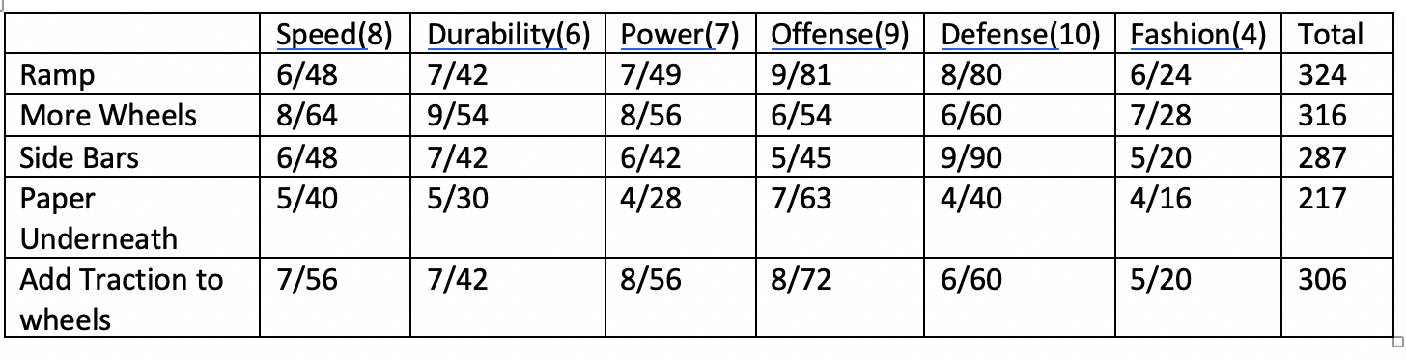

(table 2)

Idea scores explained:

The ramp was the idea that ended up scoring the highest, because it was well rounded overall and scored very high in our two most important categories. It got a relatively low score in speed because we were worried that the ramp dragging along the ground would create friction and slow our bot, and scored moderately in power and durability as well. We were unsure of a way to attach it so securely that it would stay on constantly, and did not think that the ramp itself added that much pushing power to the robot, so it scored a 7 in each. Offensively, the ramp shone because of its ability to disempower the opposing team’s robot, and defensively as well as it theoretically would prevent opposing teams from pushing it from the front. And as for fashion it scored relatively low because we couldn’t think of a way to make it pretty. The extra wheels idea scored second highest. Adding more wheels gives some extra boost, so it scored well in speed, and attaching them at the rear is fairly safe, so there would have been low chance of them falling off, so they scored well in durability. They added extra pushing power as well, but didn’t really add any specific offensive or defensive powers, so scored low in those departments. As far as side bars go, we were worried that they might interfere with our wheels and reduce speed, so they scored low there. Similarly to the ramp we could not think of a way to attach them incredibly securely, so they scored low there, and didn’t add any pushing power to the robot so scored low there as well. Offensively, side bars wouldn’t contribute to the robot as we can’t push the enemy with our sides, but scored very well in defense as it allows us to protect our sensors and wheels, and help prevent us from being pushed. They would have been pretty ugly though, so they scored low in fashion as well.

Paper underneath the sensors would have been very effective if not for all of the drawbacks. Dragging a piece of paper along the ground by our robot would have increased friction and slowed it, with possibility to become lodged in our wheels and interfere there as well. Paper isn’t incredibly durable itself either, so speed and durability were both given fives. Paper would have added nothing to pushing power, and could have interfered with our sensors and wheels as well if it got crumpled up, so scored very low in power. Offensively, the paper had the ability to function very well by interfering with opposing side sensors and causing them to trigger or drive off the mat without realizing it, but getting the paper in a position to work would have been extremely difficult without interfering with our robot as well. It didn’t add much to defense, and looked ugly as well, so it scored low in both of those areas as well. While adding traction to the wheels is a good way to add power, we were worried that it may have made the robot move slower as well, so it scored poorly in speed but well in power. There was no risk of the addition falling off, so it scored well in durability as well. The added traction would have been helpful in head to head struggles, so it scored decently well in offense, but did not really add any defensive capabilities. It also would not have changed the overall look of our robot, so fashion did not score high either. So once we calculated the totals for the matrix, the ramp and extra wheels scored highest, so we went with those two solutions for our final robot. However, after prototyping the extra wheels and experiencing difficulties wiring the motor driver (which takes up a ton of PWM pins on the redboard) to our somewhat crowded breadboard and redboard, as well as difficulty keeping it within the length restriction, we were forced to go with our third highest scoring solution which was added traction to the wheels instead.

Mental Blocks:

We encountered a few mental blocks when brainstorming design ideas. Our ideas were too repetitive, and lacked individuality from each other. In order to overcome this problem, we applied some of the techniques we learned from the readings. We looked at pictures and videos of real sumo wrestlers, and tried to apply some of their techniques to our robots. Particularly, we saw a video of a sumo wrestler lift up his opponent to make it impossible for him to resist being moved out of the ring. This gave us the idea to give our robot the ability to do the same thing, by way of attaching a ramp to the front of our robot to resist the opponent’s traction. This reopened our minds, and let the creative juices flow once more.

**Chapter 3 - Final Design** (figures 9&10)

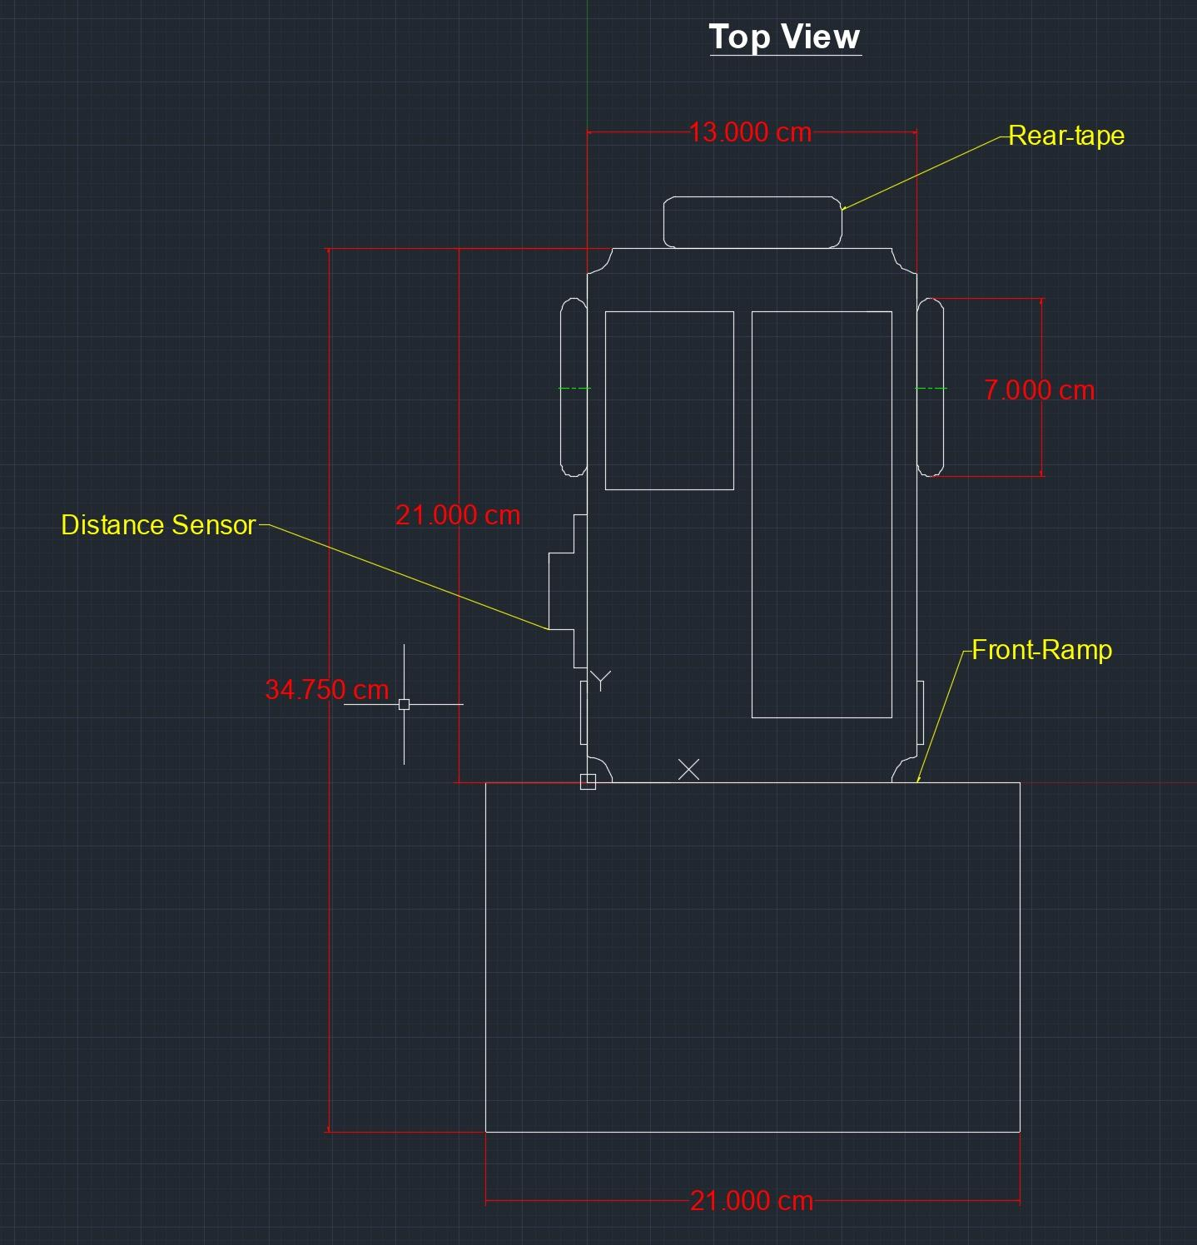

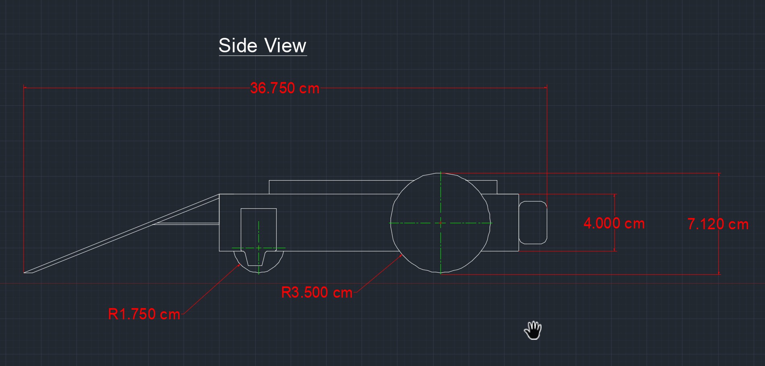

After a lot of brainstorming, we had a couple of ideas that made the final cut. These included a distance sensor on the side, a ramp on the front, and wheels on the back powered by a motor driver. We began trying to make the motor driver work for the wheels in the back. We successfully attached the two wheels to the servo, but struggled to get the motor driver to work with our breadboard despite trying multiple breadboards and motor drivers. We ended up scrapping the idea anyway due to length restrictions as using the ramp plus the wheels would lead to Blop Bot exceeding 16inches. The ramp was attached to the front using hot glue and a pencil to serve as an intermediate between the metal frame and the wooden ramp. We felt the pencil fulfilled the space in between the two objects fairly well so that our ramp could be angled towards the floor. The ramp was initially too long and would lift the front half of the robot off of the mat. The ball used for stability near the front of Blop Bot did not touch the floor and we knew this would be an issue. We trimmed the ramp using sandpaper and scissors. It was already attached to Blop at the time so a saw was out of the question and we did not need to trim the ramp too much. The distance sensor was fairly easy to attach. We used the same nuts and bolts as we did in sumo 1 except instead of placing it in the front we placed the sensor on the side. Looking back we should have either put it on the other side or used two sensors. Our goal was to turn towards a robot if detected from the side but we programmed Blop Bot to continuously turn left while the sensor was on the right side. This meant the sensor was continuously facing the outside of the circle instead of the inside where the opposing robot could be spotted. We also added tape to the back of our robot mid competition to add resistance from being picked up by opposing ramps.

In the end, the final design of the robot looked similar to the first robot but with the additions mentioned above. We decorated our ramp with a face and used pipe cleaners to look like arms. We also used pipe cleaners to keep wires on our breadboard from getting tangled and also to group wires that were associated with certain components together. Other than that we just had the sensor on the side with a pink protector and our side sensors on the side.

**Chapter 4 - Conclusion**

The important aspects throughout this project proved to be teamwork, dedication, and improvisation/quick-thinking. Leading up to competitions, each member of the group devoted substantial time to the robot-making process to ensure success in the ring. In order to achieve a well-programmed, structurally sound, competitive final robot, we had to work together and compromise at times, as well as devote time and effort to the initiative during our multiple meetings. During the competition, we had to remain vigilant and be quick on our feet to add optimal last-minute improvements to our robots to secure victory in the ring.

In terms of any decision-analysis performed leading up to the final design, we successfully implemented the results from our idea-scoring matrix into our robot for Sumo 2. As the ramp and duct-taped wheels proved to be the most feasible and high-ranking ideas, we incorporated those two specifically.

During the competition, our robot initially did not start off well. Going into the first round, we found out that our ramp had its imperfections. Our robot went against another robot with a ramp, and the opposition was able to swiftly scoop our robot up and push it out of the ring. We found the problem to be that our ramp had a little bit of space between the ground and the bottom, so it was vulnerable to being picked up by other ramps lower to the ground. After being defeated by this robot (which ended up winning the whole competition), we made a quick mid-competition adjustment. We attached a popsicle stick onto the ramp such that it would slightly protrude off the ramp on the bottom so it would slide against the ground. This way, it would prevent our robot from being picked up like it did in the first round. After making this adjustment, our robot was able to win consecutive games as other ramps were not able to pick ours up. Overall, we placed in second after losing to the same robot that defeated us earlier for a second time. However, it was a much closer match and our robot did not get picked up and pushed out of the ring as easily.

In terms of what went well during the competition, our code was one of the stronger aspects of our robot during the competition. Our side sensors never failed because of our code, so our robot never ran out of the ring by itself. While our code wasn’t too complicated, it worked properly and often outperformed the other robot in the ring. For the most part, the ramp on the front worked, especially when competing against robots without ramps. It provided both offense and defense. And against some robots, it was even able to push the competition out of the ring in just a few seconds. With regards to what didn’t go so well, it would have to be the little space between the ground and the ramp which allowed our robot to be picked up. As mentioned before, this minimal space made the difference in either being picked up or picking up the other robot.

**Chapter 5 - Recommendations & Reflections**

After participating in the second competition with our sumo robot, we learned a lot about our robot. The ramp on our robot seemed to be the right idea, as a few other robots also had the same design and the one that won the competition also had a ramp. We could have improved the ramp, so it wouldn’t have been picked up by the other robots with ramps, as mentioned earlier. During our building process, we decided to trim the bottom of the ramp a few millimeters so that it would barely be above the ground as it moved forward. If we did this competition again, we would have not trimmed the ramp and possibly sanded the bottom so that it would be thinner. The winner between the two robots with ramps came down to which one had a ramp lower than the other, along with the stronger ability to pick the other one up.

We would also like to improve our code to be more sophisticated, Even though our code worked perfectly during the competition and often aided our robot in beating the opponent, it could be improved. We could possibly alter the distance sensor code, such that it would be more efficient at detecting other objects in range. The code could also be smoothed out so there would be no chance for errors while the robot was turned on. While the distance sensor worked, it was rarely used during the competition. This is because we noticed that the other robot was often on the side that did not have the distance sensor. If we were to handle the placement of the distance sensor differently, it should have been on the other side of the robot or we should have used a distance sensor on both sides. This way, the sensor would be able to be used against other robots and work as intended. Overall, we are content with the way our Sumo Robot 2 turned out and would just make a few modifications if we were to do the competition again.

**Appendices:**

The Code



